# Project Design Phase-II

**Data Flow Diagram & User Stories**

|  |  |
| --- | --- |
| Date | 03 October 2022 |
| Team ID | PNT2022TMID30621 |
| Project Name | Skill/Job Recommendation System |
| Maximum Marks | 4 Marks |

# Data Flow Diagrams:

A Data Flow Diagram (DFD) is a traditional visual representation of the information flows within a system. A neat and clear DFD can depict the right amount of the system requirement graphically. It shows how data enters and leaves the system, what changes the information, and where user data is stored.

Example: DFD Level 0 (Industry Standard)

# Example: [(Simplified)](https://developer.ibm.com/patterns/visualize-unstructured-text/)

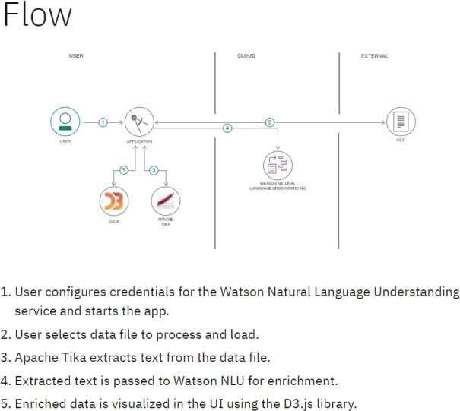

chatbot

IBM DB2

ADMIN

SKILL AND JOB RECOMMENDER APPLICATION

# User Stories

Use the below template to list all the user stories for the product.

|  |  |  |  |  |  |  |
| --- | --- | --- | --- | --- | --- | --- |
| **User Type** | **Functional Requirement (Epic)** | **User Story**  **Number** | **User Story / Task** | **Acceptance criteria** | **Priority** | **Release** |
| Customer (Web user) | Registration | USN-1 | As a user, I can register for the website  by entering my email, password ,user name, and confirm password . | I can access my account  /dashboard | High | Sprint-1 |
|  |  | USN-2 | As a user, I will receive confirmation email once I have registered for the website | I can receive confirmation email & click confirm | High | Sprint-1 |
|  |  | USN-3 | As a user, I can register for the website through Facebook | I can register & access  The dashboard with facebook Login | Low | Sprint-2 |
|  |  | USN-4 | As a user, I can register for the website through G-mail. |  | Medium | Sprint-1 |
|  | Login | USN-5 | As a user, I can login to the website by entering email & password |  |  | Sprint-1 |
|  | Dashboard | USN-6 | As a user, I enter the dashboard and search job opportunities. |  |  |  |
| Customer (Mobile user) |  |  |  |  |  |  |
|  |  |  |  |  |  |  |
| Administrator |  |  | As an administrator, I recommend new job who are waiting job |  |  |  |
|  |  |  | As an administrator, I can access and store all the details about users in IBM DB-2. |  |  |  |
|  |  |  |  |  |  |  |
|  |  |  |  |  |  |  |
|  |  |  |  |  |  |  |